DAYTONA STATE COLLEGE
Accelerated
BACHELOR OF SCIENCE – CARDIOPULMONARY SCIENCE

Pre-requisite
Respiratory Therapists Subplan:
- Completion of an Associate of Science (AS) or Associate of Applied Science (AAS) from a regionally accredited institution in Respiratory Care from a CoARC accredited program
- This program has received provisional accreditation by the Commission on Accreditation for Respiratory Care (CoARC).

Allied Health Subplan:
- Completion of an Associate of Science (AS) from a regionally accredited institution in:
  - Cardiovascular Technology from a programmatically accredited program recognized by CHEA
  - Emergency Medical Services with paramedic certification from a CAAHEP accredited program
- This program is NOT a CoARC accredited entry to practice program or CoARC accredited Degree Advancement program and DOES NOT allow graduates to take exams offered by the National Board for Respiratory Care.

Application requirements include official transcripts evaluated by DSC, with a minimum overall GPA of 2.0.

Program Courses
These may be taken in any semester the course is offered and in any sequence except for the Capstone course, which must be taken during the final semester of study.

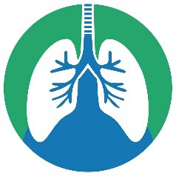
All General Education requirements must be completed within first 12-hours of upper division courses. Candidates without an A.A. degree should speak to an academic advisor.

Additional lower-division Requirements: Microbiology with Lab
Human Anatomy & Physiology I and II with Lab Must be completed prior to RET4950.

Program Specific Requirements: RET 3536 Cardiopulmonary Rehabilitation
HSA 4107 Health Services Administration
HSC 3730 Research Methods for Health Professions RET 4245 Advanced Life Support
RET 4445 Cardiopulmonary Diagnostics RET 4354 Advanced Pharmacology
RET 3041 Cardiopulmonary Education & Promotion HSC 4550 Pathophysiology for Health Care
HSC 4645 Legal & Ethical Aspects of Health Care
HSA 4383 Quality Management & Process Improvement RET 3960 Professional Credentialing
RET 4950 Cardiopulmonary Capstone

Additional Information
The program courses will be offered during two of the three semesters.
The program is 100% on-line with no face-to-face requirement, with options to participate in campus events.

The program is accelerated with some courses meeting for A or B term semesters.
Total Credit Hours required: 36 Associate of Arts General Education Core & Electives
36 AS or AAS degree program major specific courses
12 Additional lower-division science course requirements 36 BS Cardiopulmonary Science program specific
120 Total

The cost of the program will vary depending on how many credits are completed prior to start. In-state tuition cost is $102.38 per lower division credit hour and $120.32 per upper division credit hour. This program is eligible for financial aid.

Graduates will have expanded scope of care in the cardiopulmonary field with opportunities for leadership and education advancement, high complexity testing and potential for Telehealth services and direct provision of services through CMS. Note that this degree does not make you eligible for board exams in any healthcare discipline.

Applications are accepted year-round.
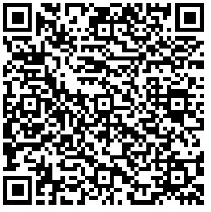
Visit our website by typing “Cardiopulmonary” into the Daytona State College website or https://www.daytonastate.edu/academic-departments/college-of-health-and-public- services/school-of-health-careers/bachelor-cardiopulmonary-science.html

To be eligible for graduation, students must successfully pass one of the following:
- National Board for Respiratory Care board exams and hold the RRT credential.
- Cardiovascular Credentialing International exam and hold either the RCES or RCIS credential
- National Registry of Emergency Medical Technician Paramedic (NREMT-P) Exam or hold the State of Florida Paramedic Certification
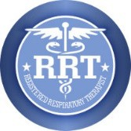
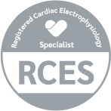
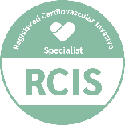
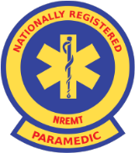
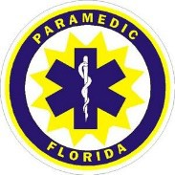

For more information, please contact:
Admissions Office | admissions@daytonastate.edu | 386-506-3759
RC / CPS Program Director – Melanie McDonough | melanie.mcdonough@daytonastate.edu | 386-506-3759 Academic Advisor – Melissa Brown | melissa.brown-mack@daytonastate.edu | 386-506-3052
AVP Associate of Arts – LaKisha Holmes l Lakisha.Holmes@daytonastate.edu l 386-506-3769

See the website for the anticipated schedule of courses, but offerings are subject to change. Courses may be closed due to low enrollment.

